**BASIC NETWORKING COMMANDS IN WINDOWS OPERATING SYSTEM**

**EX NO:01 DATE:27/07/2024**

**ROLLNO:231901048 NAME: SHAMRUDHA VARSHINI.P**

The Windows operating system provides its user with a powerful tool, Command Prompt, which allows the user to access and configure system settings and data. The network commands prove helpful when there is a need to configure or troubleshoot the network settings of our system.

**1. IPCONFIG**

The IPCONFIG network command provides a comprehensive view of information regarding the [IP address](https://www.simplilearn.com/tutorials/cyber-security-tutorial/what-is-an-ip-address) configuration of the device we are currently working on.

The IPConfig command also provides us with some variation in the primary command that targets specific system settings or data, which are:

* IPConfig/all - Provides primary output with additional information about network adapters.
* IPConfig/renew - Used to renew the system’s IP address.
* IPConfig/release - Removes the system’s current IP address.

Command to enter in Prompt – ipconfig

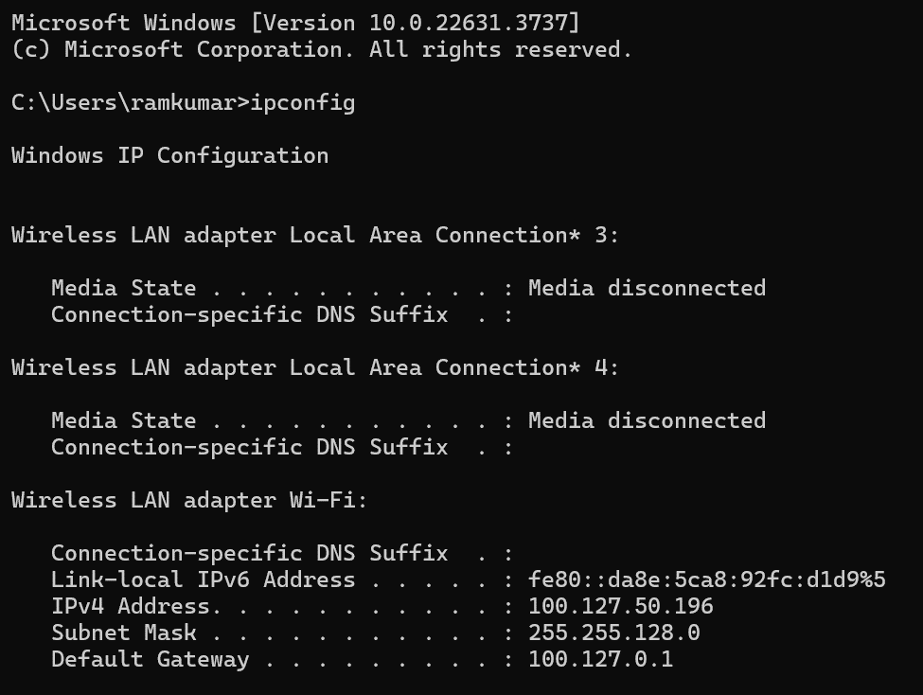

**2. NSLOOKUP**

 The NSLOOKUP command is used to troubleshoot network connectivity issues in the system. Using the nslookup command, we can access the information related to our system’s DNS server, i.e., domain name and IP address.

Command to enter in Prompt – nslookup

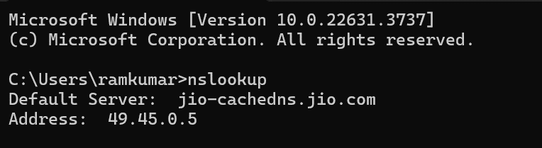

**3. HOSTNAME:**

The HOSTNAME command displays the hostname of the system. The hostname command is much easier to use than going into the system settings to search for it.

Command to enter in Prompt – hostname

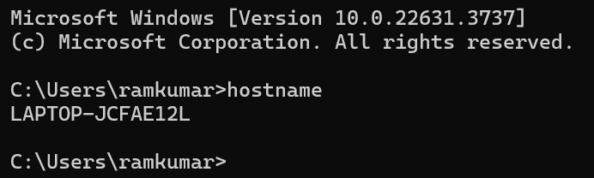

**4. PING**

The Ping command is one of the most widely used commands in the prompt tool, as it allows the user to check the connectivity of our system to another host.

This command sends four experimental packets to the destination host to check whether it receives them successfully, if so, then, we can communicate with the destination host. But in case the packets have not been received, that means, no communication can be established with the destination host.

Command to enter in Prompt - ping [www.destination_host_name.com](http://www.destination_host_name.com)

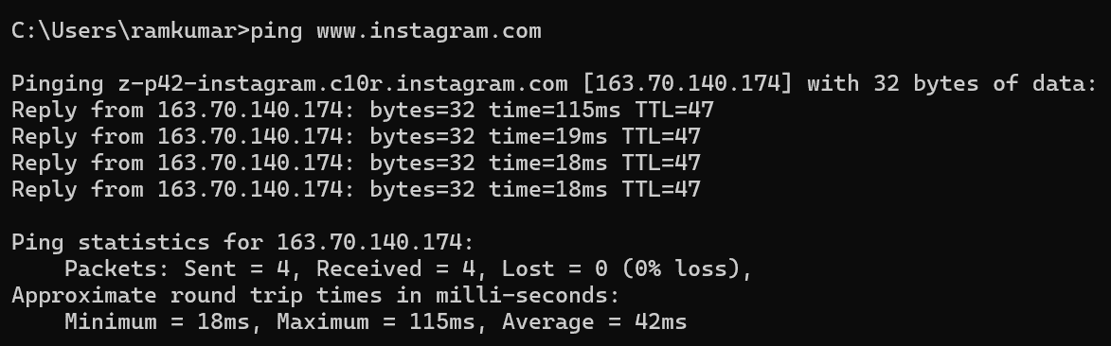

**5. TRACERT**

The TRACERT command is used to trace the route during the transmission of the data packet over to the destination host and also provides us with the “hop” count during transmission.

Using the number of hops and the hop IP address, we can troubleshoot network issues and identify the point of the problem during the transmission of the data packet.

Command to enter in Prompt- tracert IP-address OR tracert [www.destination_host_name.com](http://www.destination_host_name.com)

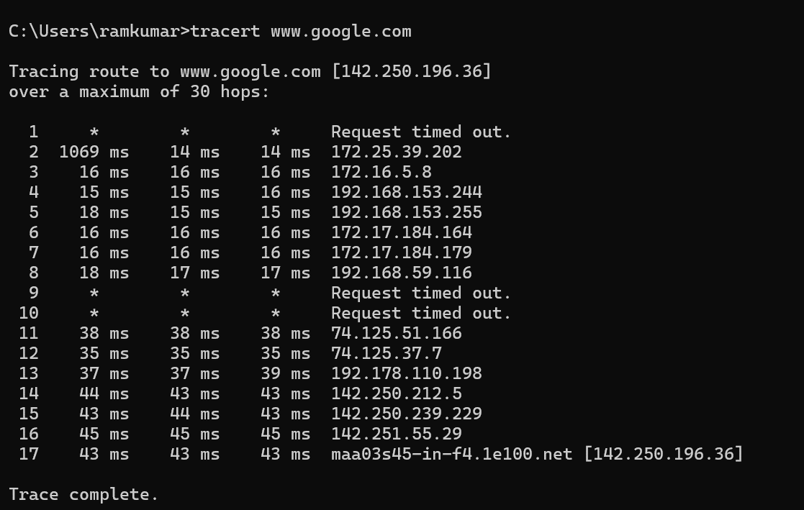

**6. NETSTAT**

The Netstat command as the name suggests displays an overview of all the network connections in the device. The table shows detail about the connection protocol, address, and the current state of the network.

Command to enter in Prompt – netstat

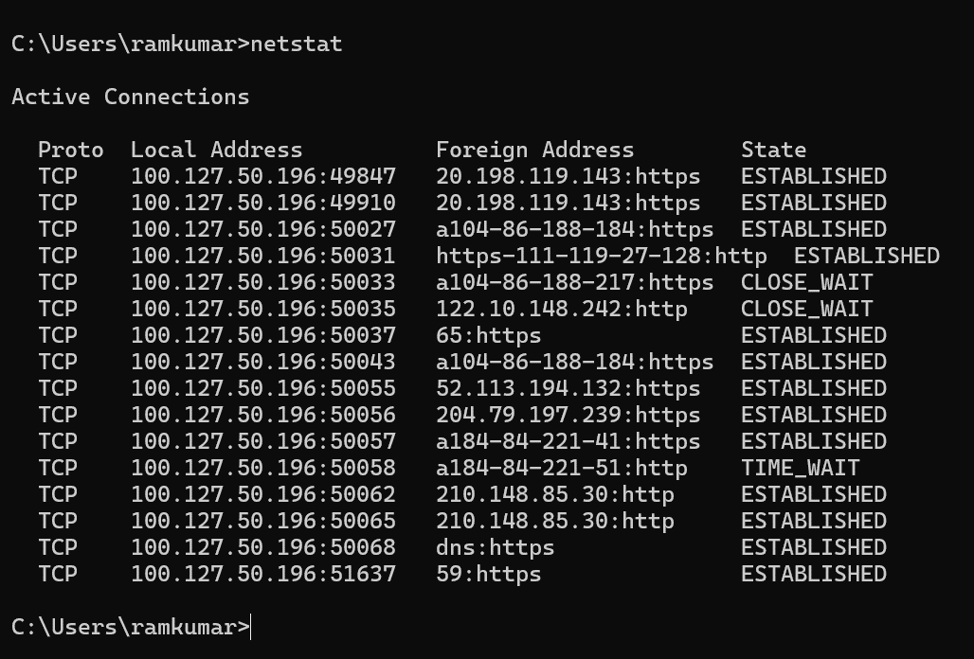

**7. ARP(Address Resolution Protocol):**

The ARP command is used to access the mapping structure of IP addresses to the MAC address. This provides us with a better understanding of the transmission of packets in the network channel.

Command to enter in Prompt – arp

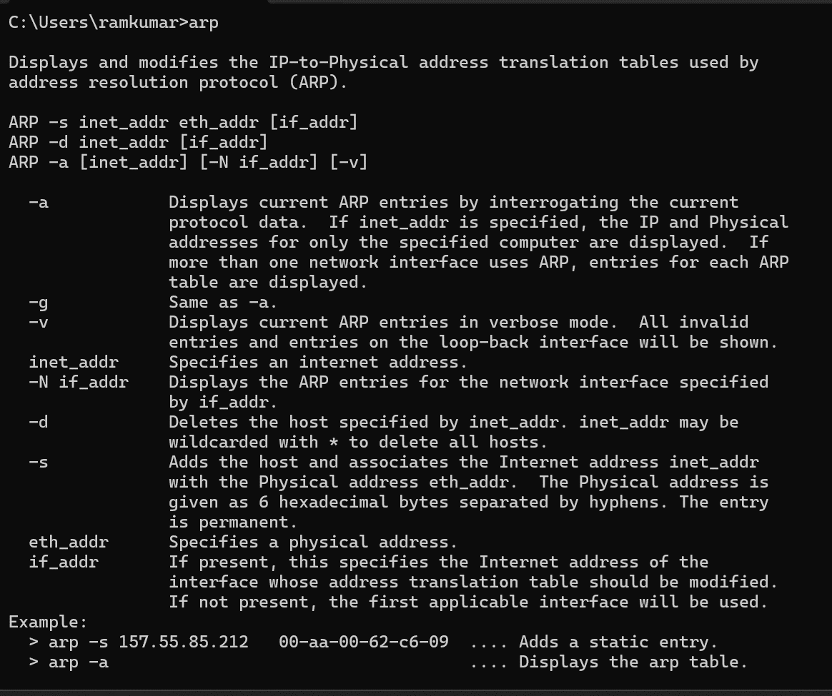

**8. SYSTEMINFO**

Using the SYSTEMINFO command, we can access the system’s hardware and software details, such as processor data, booting data, Windows version, etc.

Command to enter in Prompt – systeminfo

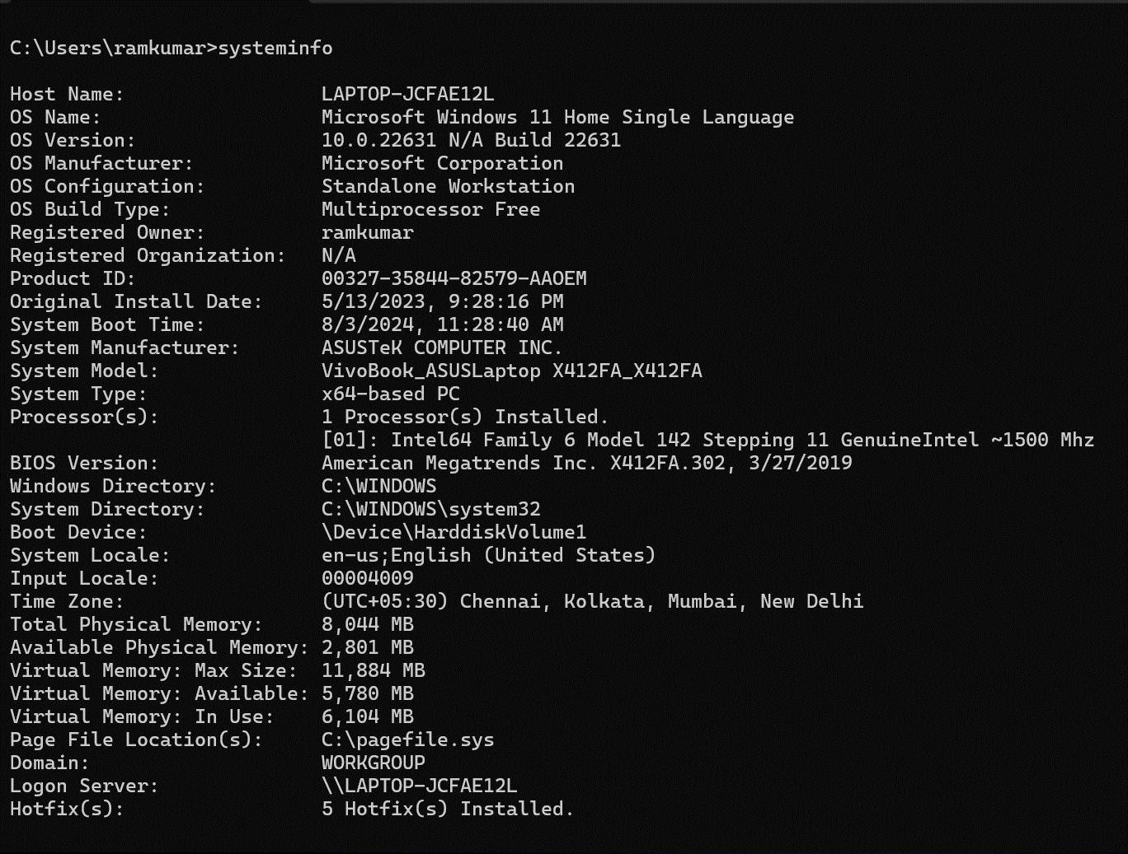

**9. ROUTE:**

Provides the data of routing data packets in the system over the communication channel.

Command to enter in Prompt – route print

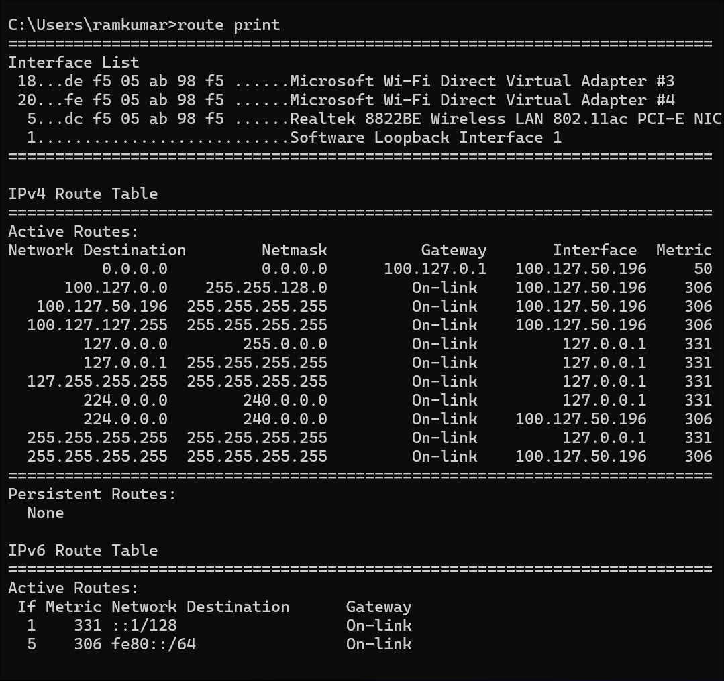

**10. NETSTAT**

It is used to get the over view of the currently connected networks from our system.

Command to enter in Prompt – netstat

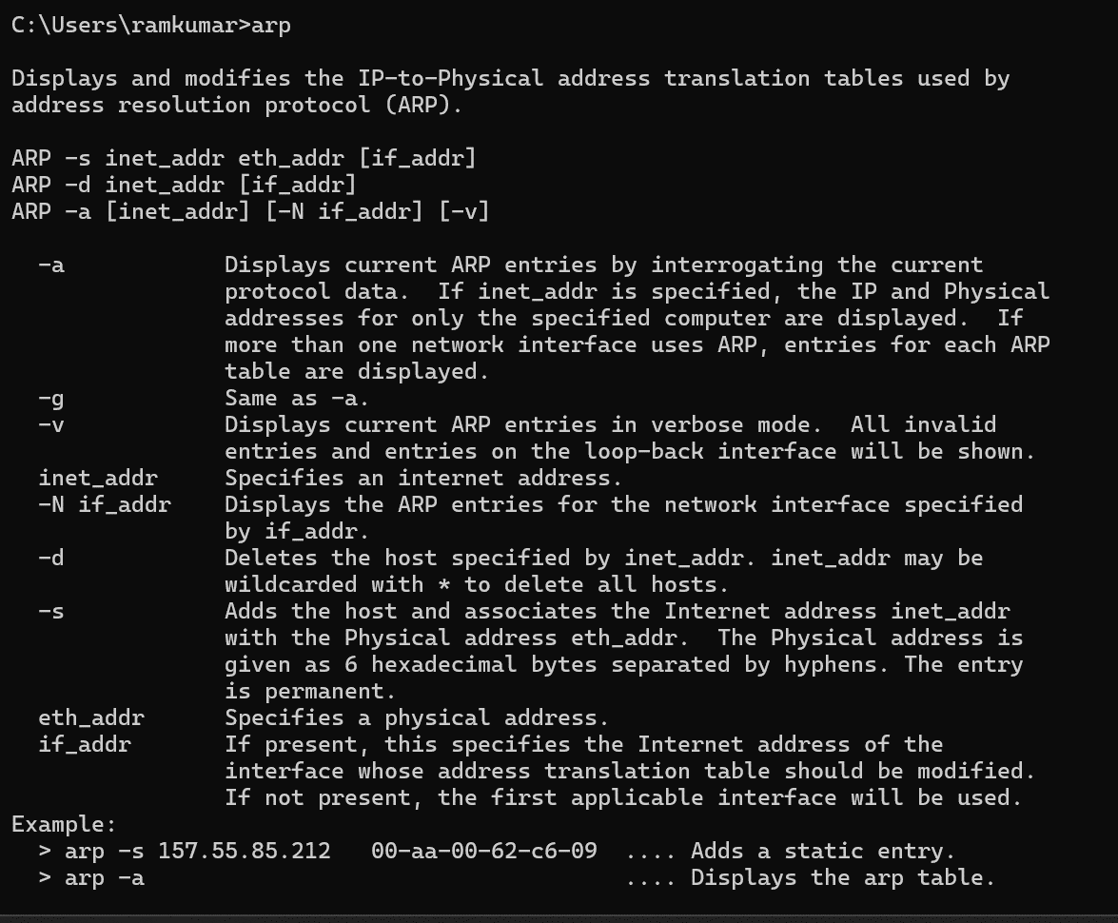

**CONCLUSION**

Understood the need of using network commands and the way to implement them in the Windows command prompt and also learned about the different network commands to troubleshoot and configure the system's network settings.